*Florida International University*

*School of Computing and Information Sciences*

CIS 4911 - Senior Capstone Project

Feature Document

User Story #1172

# **Add Guideline Videos**

Team Member:

Franco Hernandez

Product Owner(s):

Masoud Sadjadi

Mentor(s):

Mohsen Taheri

Instructor: Masoud Sadjadi

# **User Story - Add Guideline Videos**

* As a user, I would like to watch videos available in the login page so that it would be easy to use the VIP website.

## **Use Case**

Use Case ID: (VIP-1172)

Details: Make guidelines videos appear on the login page and arrange them according to the current login design.

Actor: Faculty, student

Pre-Condition:

* Faculty and student has navigated to the login page.

Description:

1. Use case begins when a faculty member click on the User Guide for Faculty video
2. Use case begins when a student click on the User Guide for Student video

Post-Conditions:

1. Users should be able to navigate and use the VIP website without constraints.

Alternative Course of Action

N/A

Exceptions:

N/A

Related Use Cases:

N/A

Decision Support:

Frequency: Low: User might only use videos once in order to use the VIP website

Criticality: Low: This feature has no impact on the rest of the sites performance

Risk: Low.

Constraints:

1. Usability:
   1. Requires no experience.
2. Reliability:
   1. Availability – Videos are always available on login page.
3. Performance:
   1. Videos will play after 5 sec of been clicked.
4. Supportability:
   1. All modern web browsers should be supported.

Modification History:

Owner: Franco Hernandez

Initiation date: 10/19/2016

Date last modified: 10/23/2016

Use Case Diagram

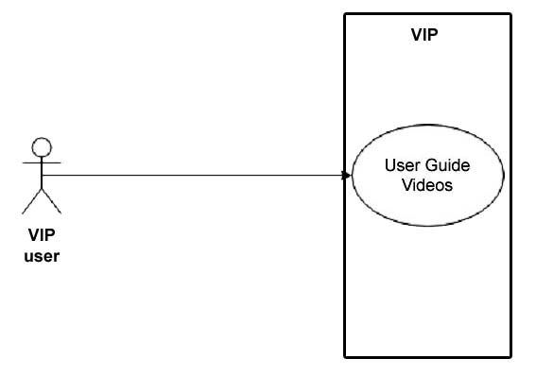

Sequence Diagram

N/A

Class Diagram

N/A

Unit & Integration Tests:

Test Case 1 (Sunny Day)

ID: VIP-SD-1172-01

Purpose:

* Test that guideline videos appear on the login page.

Precondition

* User navigates to the login page.

Input

* N/A

Expected Result

* Videos must be visual on login page.

Actual Result

* Same as expected.

Test Case 2 (Sunny Day)

ID: VIP-SD-1172-02

Purpose

* Test videos are functional.

Precondition

* Videos are available on login page.

Input

* User click on video.

Expected Result

* Videos plays without interruptions.

Actual Result

* Same as expected.

# **User Guide**

This User Guide begins when a user navigates to the login page and click on the guideline videos.

